
BAHIRDAR UNIVERSITY
FACULITY OF COMPUTING
Department of Software Engineering
PRICIPLE OF COMPILER DESIGN

NAME : BETELHEM TAYE

ID : 1505360

SECTION : B

SUBMITTED TO:MR WENDMU B

SUBMISSION DATE :27/042018

Deterministic parser

At each step the parser has at most one valid action to take (shift/reduce, or which production to expand).
Decisions are made using a finite amount of lookahead (often 1 token for LL(1)/LR(1)).
Examples: LL(1) (predictive) parsers, table-driven LR(1) / LALR(1) parsers and deterministic pushdown automata (DPDA).

Non-deterministic parser

The parser may have multiple possible actions at a step and may need to explore several possibilities (backtracking), or be modeled by an Nondeterministic PDA (NPDA).
Examples: backtracking recursive-descent parsers, general CFG recognition algorithms (CYK, Earley _ Earley can work non-deterministically but can be implemented efficiently).

Pros and cons

Pros:fast, predictable, efficient (linear time), generates compact parse tables, suitable for automatic parser generation.

Cons: requires grammars to be in a restricted form (no certain left recursion, no ambiguities, must be determinable with the lookahead); sometimes needs grammar transformations (left-factoring, remove left recursion).

Key differences & practical points

Deterministic parsers: single action chosen using parsing table / finite lookahead → linear time for compatible grammars.

Non-deterministic: may require backtracking or search across multiple choices → worst-case super linear (possibly exponential) unless special algorithms used.

In compiler practice:
It is prefer to use deterministic parsing (LL or LR families). If grammar is not deterministic, we transform it (left-factor, remove left recursion) or choose a stronger parser generator (e.g., LALR(1), LR(1), or GLR/Earley for ambiguous/niche grammars).

2. C++ — Stack-based parser to check balanced parentheses
#include <iostream>
#include <stack>
#include <string>
using namespace std;

bool isMatching(char open, char close) {
return (open == '(' && close == ')') ||
(open == '{' && close == '}') ||
(open == '[' && close == ']');
}

bool isBalanced(const string& expr) {
stack<char> st;

for (char c : expr) {
if (c == '(' || c == '{' || c == '[') {
st.push(c);
}
else if (c == ')' || c == '}' || c == ']') {
if (st.empty() || !isMatching(st.top(), c)) {
return false;
}
st.pop();
}
}
return st.empty();
}

int main() {
string input;
cout << "Enter expression: ";
cin >> input;

if (isBalanced(input))
cout << "Balanced\n";
else
cout << "Not Balanced\n";

return 0;
}

Out put :
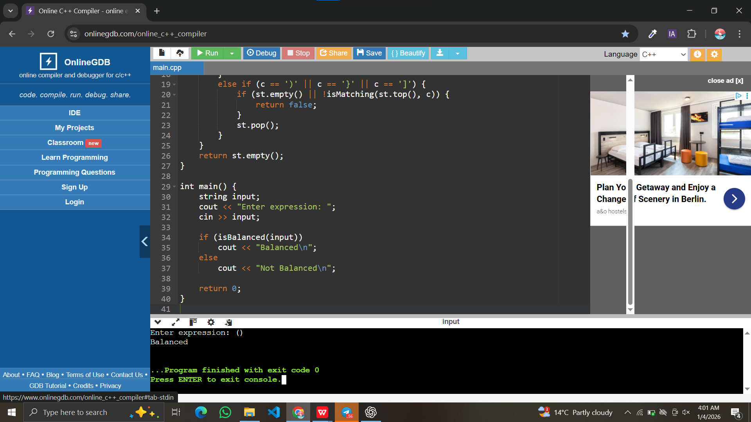

Notes:
To compile: g++ -std=c++17 balanced_parentheses.cpp -o balanced_parentheses
Example:
Input: ([]{}) → Output: Balanced
Input: ([)] → Output: Not balanced
If you only need to check round parentheses () remove []/{} handling; the logic is the same.

- Problem-solving— Grammar and parse tree
Grammar:
S → 0 S 1 | 0 1
Input string: "0011“
Derivation (leftmost):
S
S ⇒ 0 S 1 (apply production S → 0 S 1)
The inner S must produce 01, so S ⇒ 0 (0 1) 1 — that is S ⇒ 0 (S⇒01) 1
Resulting string: 0 0 1 1 → 0011
So one-step: S → 0 S 1 → 0 (01) 1 → 0011.

Parse tree (visual / ASCII):
S
/ | \
'0' S '1'
/ \
'0' '1‘
Or
S
├─ '0'
├─ S
│ ├─ '0'
│ └─ '1‘
└─ '1‘ . This tree shows the outer production S → 0 S 1 with the inner S → 01.

A diagram representation of the parse tree
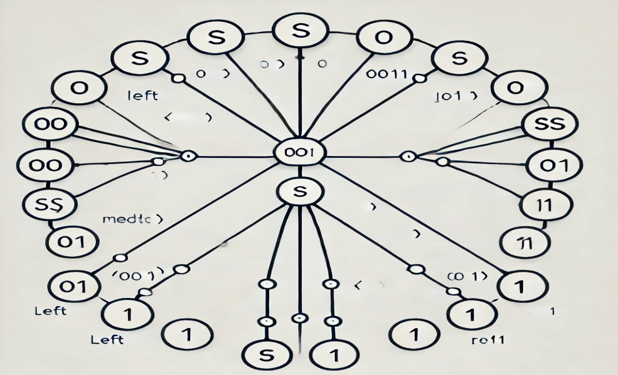

Github repository link:

https://github.com/BETELHEM-TAYE/Stack-based-parser-to-check-balanced-parentheses

